Project Design Phase-II
Technology Stack (Architecture & Stack)

Date | 05 Apr. 26
Team ID | SWTID-2026-6042
Project Name | Smart Library Request Workflow in ServiceNow
Maximum Marks | 4 Marks

Technical Architecture:
The Deliverable shall include the architectural diagram as below and the information as per the table1 & table 2
Smart Library: Architecture Highlights

- Logic (Cloud): ServiceNow Flow Designer & Virtual Agent (Core Application Logic).
- Infrastructure: ServiceNow Cloud Instance (Back-end) vs. Local IoT/Mobile (Edge inputs).
- External APIs: Integration Hub connecting to third-party Book Metadata DBs (REST/SOAP).
- Data Storage: ServiceNow CMDB (Asset/Inventory) & Foundation Tables (Patron Data).
- ML Interface: Predictive Intelligence & NLU Studio for recommendation/voice models.

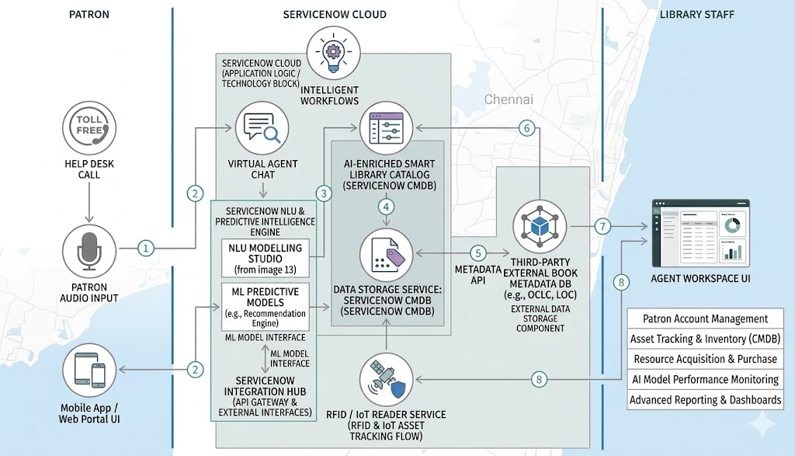

Table-1 : Components & Technologies:
S.No | Component | Description | Technology
 | User Interface | Interaction points for patrons and librarians. | ServiceNow Service Portal (AngularJS), Mobile Agent App, Virtual Agent.
 | Application Logic-1 | Core borrowing and return workflow automation. | ServiceNow Flow Designer / JavaScript (Business Rules).
 | Application Logic-2 | Natural Language Processing for voice/text search. | ServiceNow NLU (Natural Language Understanding).
 | Application Logic-3 | Automated book recommendations and classification. | ServiceNow Predictive Intelligence (ML).
 | Database | Relational data for patrons and lending rules. | ServiceNow Internal MariaDB (Relational).
 | Cloud Database | Asset and metadata repository. | ServiceNow CMDB (Configuration Management Database).
 | File Storage | Digital resource storage (e-books, manual PDFs). | ServiceNow Attachment Table / Managed Cloud Storage.
 | External API-1 | Retrieval of global book metadata/titles. | Google Books API / OCLC WorldCat API (REST).
 | External API-2 | User authentication and identity verification. | Azure AD / Okta (SAML 2.0 / OAuth 2.0).
 | Machine Learning Model | Pattern recognition for inventory and fraud detection. | ServiceNow AI Search & Clustering Models.
 | Infrastructure (Server / Cloud) | Multi-instance cloud architecture deployment. | ServiceNow Cloud (AOB), Mid Server (for Local IoT/RFID).

Table-2: Application Characteristics:
S.No | Characteristics | Description | Technology
 | Open-Source Frameworks | Web components and client-side scripting for the Portal. | AngularJS, Bootstrap, Node.js (MID Server).
 | Security Implementations | Role-based access (RBAC), multi-factor authentication, and data encryption. | SAML 2.0, OAuth 2.0, AES-256 Encryption, ACLs (Access Control Lists).
 | Scalable Architecture | Multi-instance architecture that separates web, application, and data layers. | Advanced High Availability (AHA), ServiceNow Multi-Instance Cloud.
 | Availability | Geography-redundant data centers with automated failover. | Load Balancers, N+1 Redundancy, ServiceNow AHA Architecture.
 | Performance | Optimized query execution and edge-side processing for low latency. | Semiconductor Caching, Edge Encryption, ServiceNow Integration Hub.

